(Q) What is React js ?

React is JavaScript library that is used to build user interfaces. React is a component- based library, which means that it allows developers to create create reusable UI components that can be used across different parts of an application.

(Q) What is NPM in React js?

NPM stands for Node Package Manager. NPM is used to install and manage dependencies for a React project when you create a new React project using tools like Create React App, NPM is used to install all the necessary dependencies for the projects.

(Q) What is role of Node js in React js?

When building a React application, Node js can be used to manage dependencies and to run the development server . Node.js can also be used to build the back-end of a React application, which can be used to handle requests and responses from the front-end.

(Q) What is CLI command in React js?

CLI stand for Command Line interface. CLI commands are used to create, manage , and deploy React applications.

Some of the commonly used CLI commands in React are.

1. npx create-react-app my -app: Create a new React project with name .
2. npm start: Starts the development server.
3. npm run build: Builds the production version of the application.
4. npm test: Runs the best suite for the application.

(Q) What is Components in React js?

In React, a component is a reusable piece of code that represents a part of a user interface. There are two types of components in React.

1. Class components – Class components are defined using ES6 classes and are used for more complex components that require state and lifecycle methods.
2. Functional components- Functional components , on the other hand, are defined using JavaScript functions and are used for simpler components that don’t require state of lifecycle method.

(Q) What is Header and Content Components in React js?

In React JS, components are the building blocks of a web application . They are reusable and independent pieces of code that can be used to create complex user interface .

Header Components- Header Components is used to display the header section of a web page . it usually contains the website’s logo, navigation menu, and other important information.

Content components- A content components is used to display the main content of a web page . It can contain text, images videos , and other types of media.

(Q) How to install React Js on windows, Linux operating System? How to install NPM and How to check version of NPM?

- Open terminal (Command prompt or powershell).

- Go into your desired location where you want to start react app by using ‘cd’ command in propmpt.

- Use the command ‘npm create- react- app projectname’.

(Q) How to check version of React js?

- Using package .json file.

- Using the command line.

- Using the version property of default import from React.

(Q) How to Change in components of React js?

To change components in React js,

– Create a new component.

* Import the new component
* Render the new component.

(Q) How to create a list view in React js?

import React from 'react'

import ReactDOM from 'react-dom/client'

function Car(props) {

    return <li>I am a {props.brand}</li>;

}

export default function List() {

    const cars = ['Ford', 'BMW', 'Audi'];

    return (

        <>

        <h1>The "React way" to Render a List</h1>

        <ul>

            {cars.map((car) => <Car brand ={car} />)}

        </ul>

        </>

    );

}

const root = ReactDOM.createRoot(document.getElementById('root'));

root.render(<List />);

output-

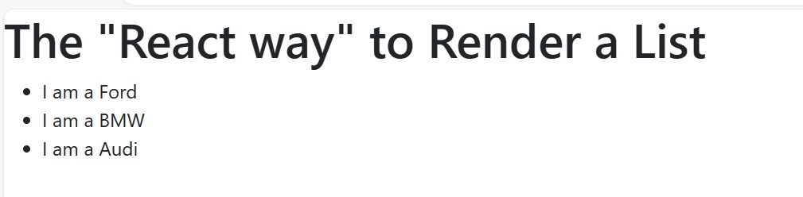

(Q) Create Increment decrement state change by button click?

import React, { useState } from "react";

import ReactDOM from "react-dom/client";

export default function Inc_dec() {

     // State variable 'count' and its updater function 'setCount'

  const [count, setCount] = useState(0);

  return (

    <>

      {/* Display the current count */}

      <p>Count: {count}</p>

      {/* Button to increment the count */}

      <button type="button" id="inc" onClick={() => setCount((c) => c + 1)}>

        inc

      </button>

      {/* Button to reset the count to 0 */}

      <button type="button" id="reset" onClick={() => setCount((c) => c - c)}>

        reset

      </button>

      {/* Button to decrement the count */}

      <button type="button" id="dec" onClick={() => setCount((c) => c - 1)}>

        dec

      </button>

    </>

  )

}

// Create a React root and render the component to the specified HTML element

const root = ReactDOM.createRoot(document.getElementById("root"));

root.render(<Inc_dec />);

output-

